# Life management

# Installation Manual

For the installation, the following is required

Either IIS or a Web App in Azure

SQL Server version 2012 or later.

Visual Studio 2015 or later version.

First open SQL Server and execute the script located in Code/Database folder named DBCreationScript.sql. That will create the database and insert some data.

Then, open the solution file located in Code/Website folder named LifeManagement.sln. Use Visual Studio 2015 for this. Make sure you modify the connection string in

the configuration file Web.config to point to the appropriate database:

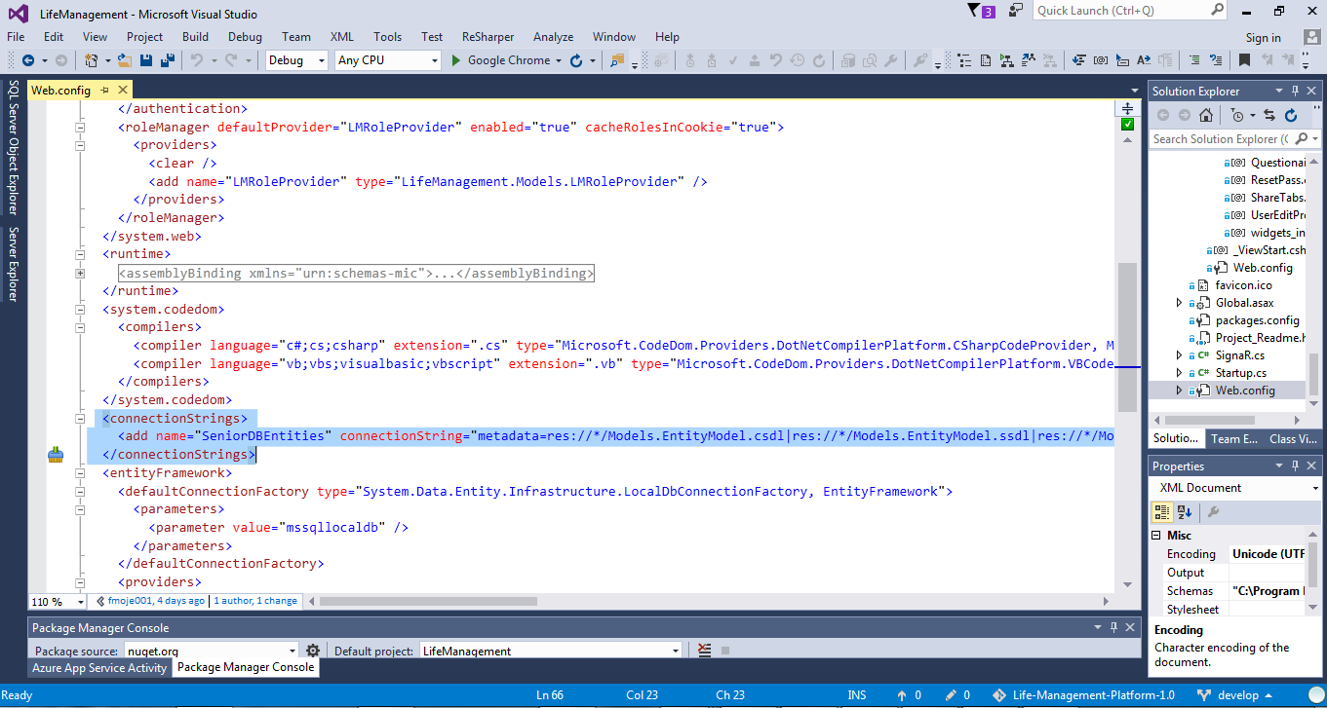

Also, Make sure everything is working properly by rebuilding and running the solution. To build it select the project file in the Solution Explorer and click the Build menu, then rebuild solution:

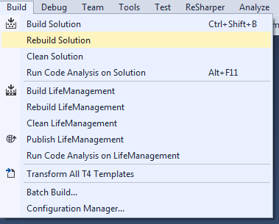

If any error comes up, it needs to be fixed before continuing to next step.

Once the solution is built, run it by pressing f5 or using the Debug menu, start debugging:

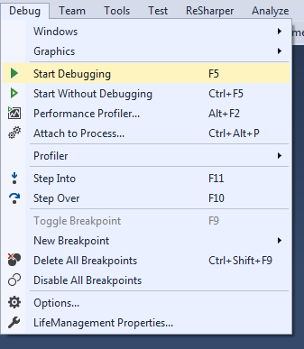

Make sure everything is working properly, if so, stop debugging in the debug menu and you are ready to publish your solution.

As of now, we are hosting the web application and database in azure but it can also be hosted in a local IIS. If you wish to do so, please refer to user guides on how to install and setup IIS for .Net framework 4.5.2.

To publish the solution, select the project file and click the Build menu and then publish Life Management.

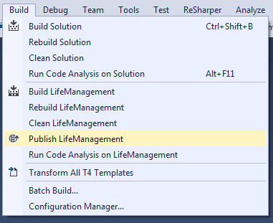

In the Profile section you are offered to create a new profile with appropriate parameters.

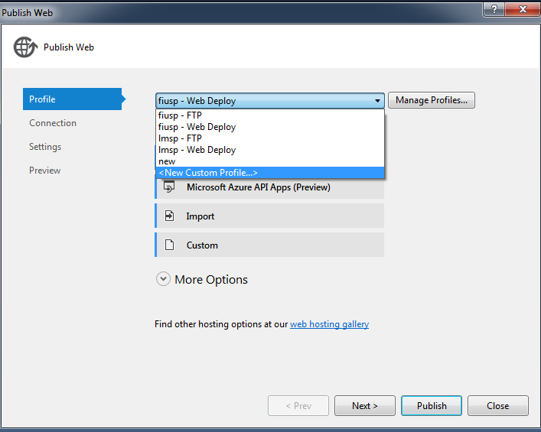

That is, you may use web deploy, ftp or file system. Each of these options have specific parameters that need to be in place before proceeding.

Click next and update information as needed and click publish once you have the option available.